2012 Consistency Club!

Consistency is a key ingredient to your success!

Reward yourself with this
‘PANDORA’ STYLE Necklace!

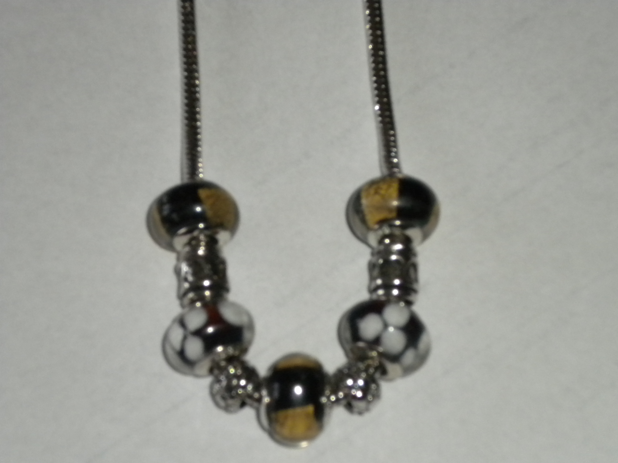

When you place a minimum $200 wholesale order 3 months in a row, the Bracelet is yours!

Then…add a glass ball or silver spacer each month with each consecutive monthly order
($200 minimum) to the company!

